**EE451 PA2**

Yixuan Zhou 3827-1583-76

P1a

﻿gcc -O3 -o problem1a problem1a.c -fopenmp

﻿srun -n1 -c4 ./problem1a

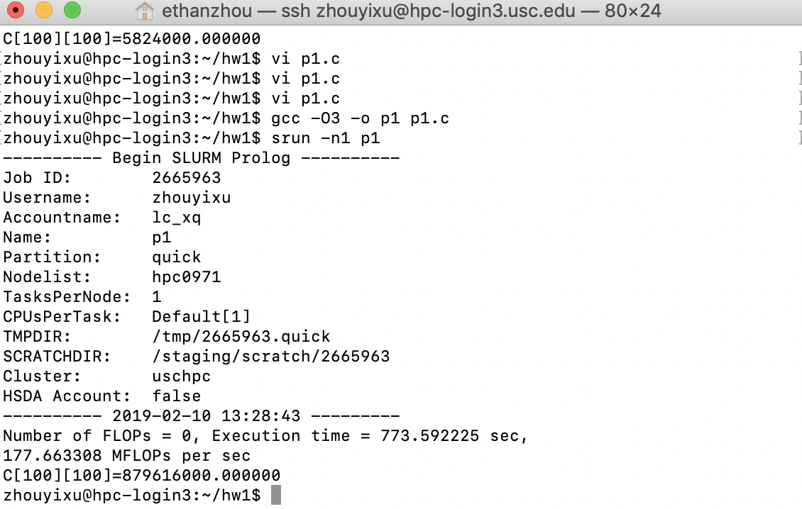

Figure . Serial

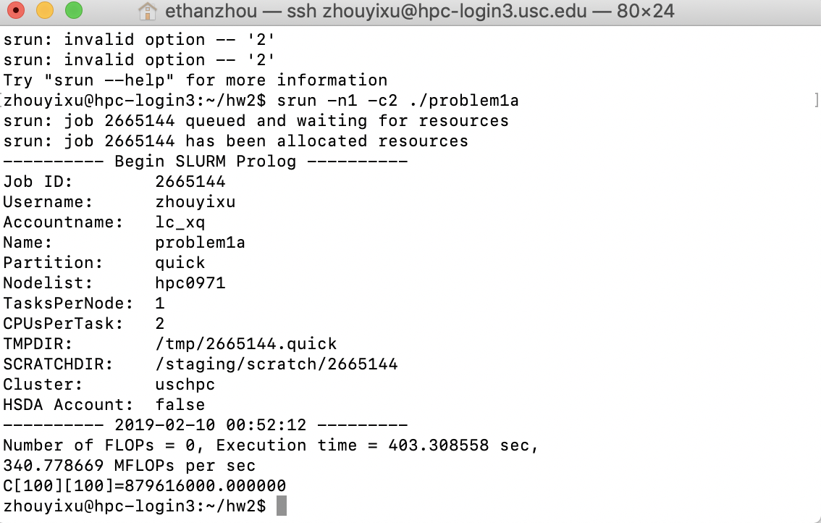

Figure . OpenMP 2 threads

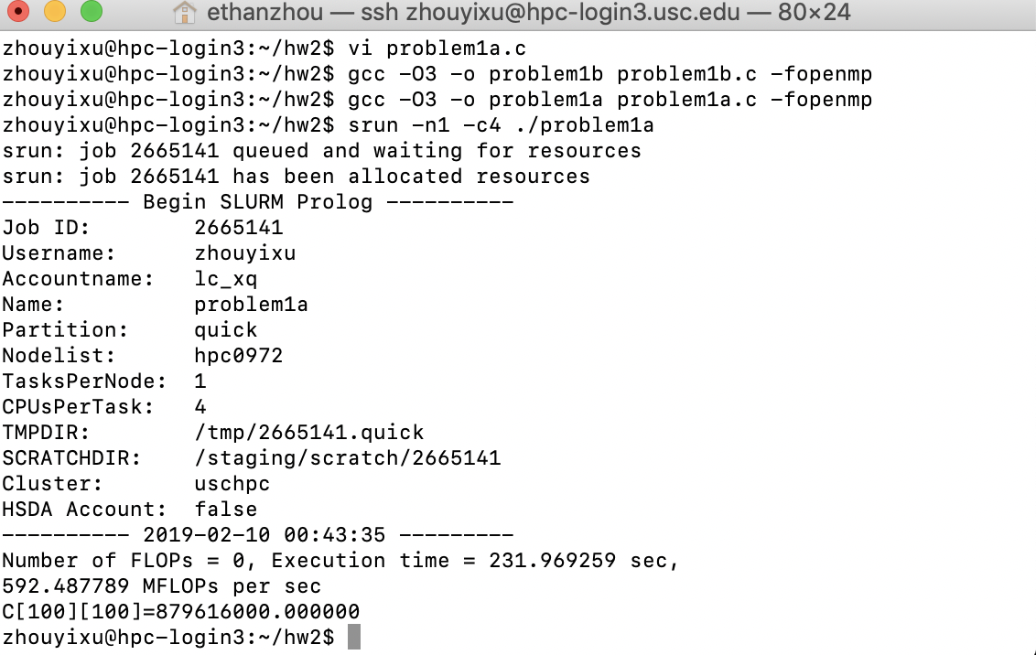

Figure . OpenMP 4 threads

The execution time is inversely proportional to the number of threads used.

P1b

gcc -O3 -o problem1b problem1b.c -lpthread

﻿srun -n1 -c4 ./problem1b



Figure . Serial

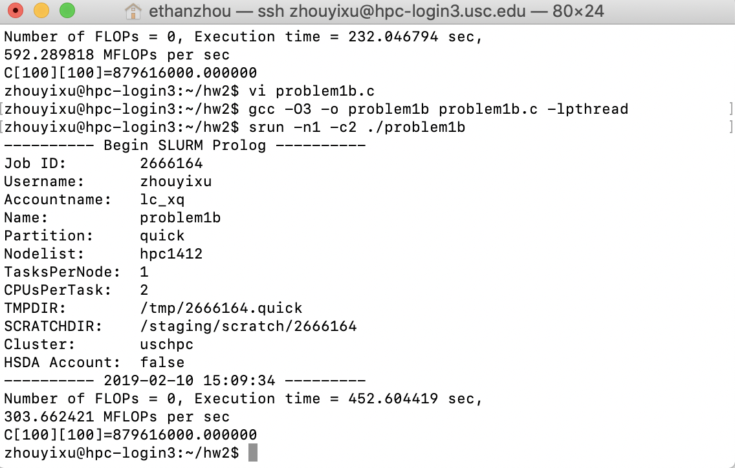

Figure . Pthread 2 threads

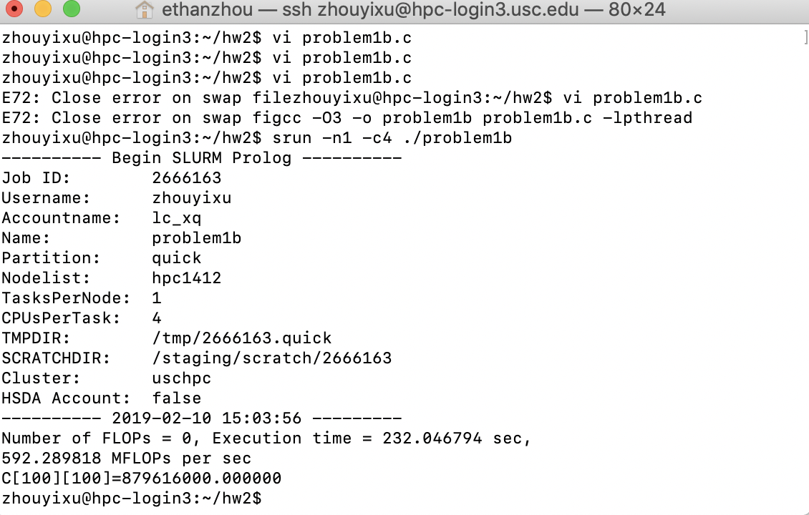

Figure . Pthread 4 threads

The execution time is inversely proportional to the number of threads used.